There are 3 tasks that are to be done in this lab

1) The first task is to collect the data using the sensor device which was already done in Lab 2. My Lab2 report is already in the Github site.

2) The second task is to transfer file in HBase. For this purpose we have to write a program which takes the file from our system and uploads it to the HBase. Since, the program has already been given in the blackboard, few changes have to be made to get the output. We can see the output in the following figure. Sensor2.txt has been uploaded to the group11 in putty.

This is the output in the program

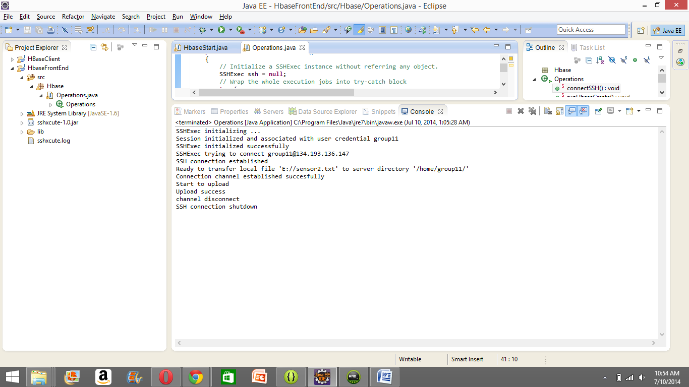

This shows that the file sensor2.txt has been uploaded to HBase (group11)

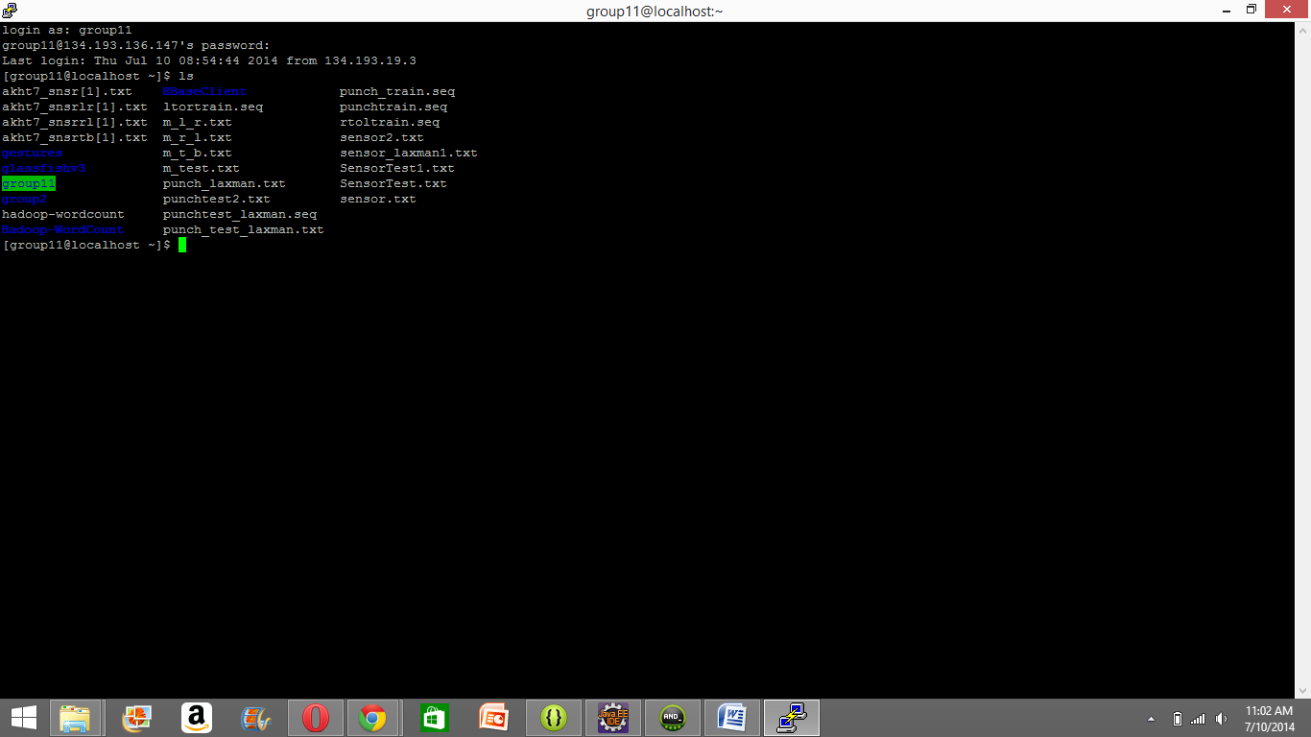

3) HBase CRUD operations

Design an Android App which has 4 buttons Create, Retrieve, Update and Delete

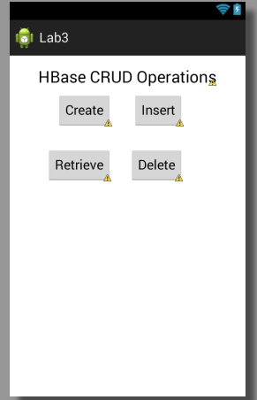

When we hit the retrieve button, we get the following result

For Retrieve

